Internal audit process |  |  |  |  |  |  |  |  |  | 
Document no |  |  | RS-MP-04 |  |  |  |  | Written by |  |  |  | Mark.Kim
Rev no |  |  | 001
Rev. date | 2022.09.27 |  |  |  |  |  |  | Department |  |  |  | QM
Revised contents |  |  |  |  |  | Drift |  |  | Review |  |  |  | Approval
 |  |  |  |  |  | / |  |  | / |  |  |  | /
Revised Items | AS IS |  |  |  |  | TO BE
Agreement | QM | R&D
 | Opinion:

[Revision history]
Revision history summary |  |  | RS-MP-04
 |  |  | Revision | 001
 |  |  | Confidential | G1
Rev. no | Rev. date | Simple description of changed contents | Author | Post
001 | 2022.09.27 | Newly established. | Mark.Kim | QM

1. Purpose and scope
The purpose of this process is to improve & maintain the quality/environment management
system through internal audit.

2. Apply scope
ramschip’s quality management activity.

3. Definition of terms
3.1 Quality/Environment audit
The checking whether quality & environment system of the ramschip is maintained according to Q/E policy and ISO global standard.
3.2 Quality management system
Organization, responsibility, resource to conduct quality management.
3.3 Auditor
Those who are qualified by requirement of this process. The audit team consists of the audit team leader and members.
3.4 Audit team leader
He has responsibility that leads the audit and report the finding issue to the CEO. After that, request corrective & improve actions each department and, re-check them whether it is applied real quality/environment activities.

4. Relevant form
4.1 Annual audit plan [RC-MP-04-F001]
4.2 Finding report [RC-MP-04-F002]
4.3 Nonconformity & improvement plan [RC-MP-04-F003]

5. Responsibility and authority
5.1 CEO
The CEO has the responsibility and authority to receive reports on audit results and to decide
necessary actions.
5.2 CQO
The CQO (Chief quality officer) consults and establishes a plan for internal audit, and has responsibility that perform internal audit on the basis of annual audit plan and report audit result & corrective actions to the CEO. And should issue them on the biz review board.
5.3 The leader each department
The head of each department is responsible for taking corrective actions for the finding issue.
5.4 Auditors
Auditor has authority to conduct audit without any interference from a third party or person.
And, they have authority to request all of material related with quality/environment activities.

6. Process map

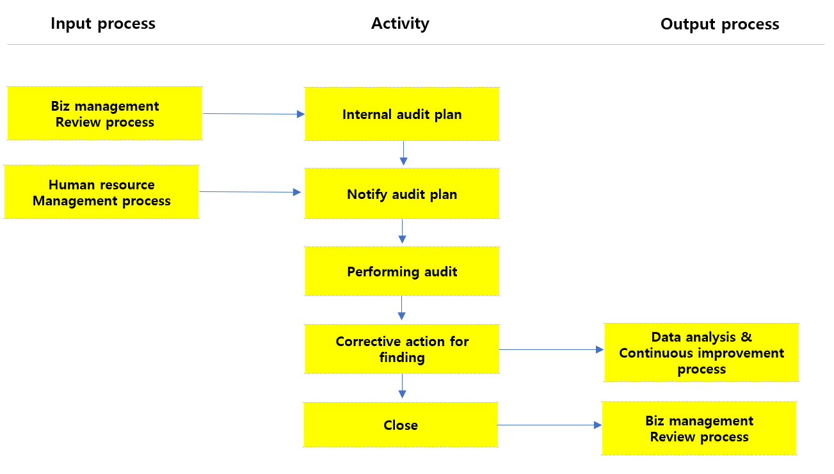
7. Process description
In  process | Input | Activity | Output | Out  process | Freq. | Review | Approval
Biz management  Review process | -. Yearly biz  Management review report | -. QM leader prepares an internal audit plan based on the  Business plan.  -. QM leader may conduct special audits in addition to regular internal audit. | -. Yearly audit plan  -. Special audit plan | N/A | 1X/Year | CQO | CEO
Human resource management process | -. Yearly audit Plan  -. Auditor certification | -. QM leader notify audit date & scope to each department 7days before audit date based on annual audit plan.  -. QM leader inform auditor’s information to each department. | -. Audit plan | N/A | Occurred | CQO | CEO
- | Audit plan | -. Audit team leader should check for finding items of the previous audit. and  conduct an internal audit to ensure that QMS/EMS is well maintained  according to the audit check list. And then, record audit contents & finding  on the check list. | -. Finding report | N/A | Occurred | CQO | CEO
- | Finding report | -. The audit team leader requests correction actions from the relevant department for nonconformities.  -. The audit team leader review corrective actions received from the relevant department whether they are reasonable or not.  -. If the corrective actions for nonconformities is done, the audit team leader report audit result to the CEO. | Nonconformity & improvement plan  Audit result report | Data analysis & continuous improvement process | Occurred | CQO | CEO
- | Nonconformity & improvement plan  Audit result report | -. The audit team leader prepares an final audit report based on the corrective actions approved by the CEO | Final audit report | Biz management  Review process | 1X/Year | CQO | CEO

8. Qualification of the internal auditor

8.1 qualification of the internal auditor
1) A person who have completed quality/environment system audit training from a certified external institution.
2) A person who has been in the company for more than 3years or has a track recode of implement
internal audit.
3) A person who have completed internal audit training program.
※ If one or more of the above requirements are met, he or shoe may be appointed to the internal auditor.
8.2 Registration of internal auditor
1) QM leader register the appointed internal auditor in the internal audit list [RS-MP-04-F-004]
2) The validity period of the certification of internal auditor is 5years, and if the qualification does not lose by
specific requirement, it is extended automatically.
8.3 Deregistration of internal auditor
1) If there is no internal audit record within the validity period of the certification.

9. Classification of the finding grade & finding code.

9.1 Classification of the finding grade
Finding grade | Description
Critical | -.
Major | -.
Minor | -
Recommendation | -
9.2 Finding code rule
▶ RS-F- Department code -XXX (XXX: serial numbers)
10. Document record & preservation
Material | Form code | Dept | Life
Annual internal audit plan | RS-MP-04-F001 | QM | 5 years
Finding report | RS-MP-04-F002 | QM | 5 years
Nonconformity & improvement plan | RS-MP-04-F003 | QM | 5 years
Internal auditor list | RS-MP-04-F004 | QM | 5 years

Appendix
Annual internal audit plan RS-MP-04-F001
Annual internal audit plan |  |  |  |  | 
□ Regular audit  □ Special audit |  |  | Date: |  | Draft |  | Review |  | Approval
 |  |  |  |  | / |  | / |  | /
Dept. | Inspection & 16949 Requirement | 1H  ( ) | 2H  ( ) | Nonconformity items |  |  |  | Corrective actions
 |  |  |  | 1H |  | 2H |  | 1H |  | 2H

Finding report RS-MP-04-F002
Finding report |  | 
□ Regular audit  □ Special audit |  | Auditor
 |  | Date
 |  | Dept.
Inspection contents | Finding (Nonconformity) |  |  | Grade

Nonconformity & improvement plan RS-MP-04-F003
Nonconformity & improvement plan |  |  | 
□ Regular audit  □ Special audit |  |  | Auditor
 |  |  | Date
 |  |  | Dept.
Ⅰ. Nonconformity
Finding No. | Description |  |  |  |  | Grade
Ⅱ. Improvement action
Reason of finding |  | Improvement action
▶ Target date:
Ⅲ. Effectiveness verification
[Verification result] |  |  |  | Date
 |  |  |  | Auditor
 |  |  |  | Completion

Internal auditor list RS-MP-04-F004
Internal auditor list |  |  | 
▶ If the internal auditor’s certification is lost, the auditor list must be  update |  |  | Draft | Review | Approval
 |  |  | / | / | /
Department | Name | Rank | Certification

